English for Marine Navigation

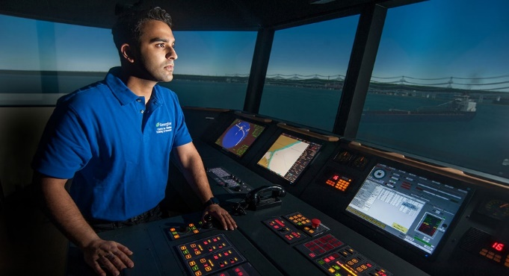
Become a leader in the global marine industry! See our outstanding facilities.
State-of-the-art facilities
The Centre for Marine Training and Research is Canada's most advanced marine simulation and research centre. Located in beautiful Owen Sound, Ontario, the facility recently underwent an extensive $8-million renovation to enhance hands-on training for students.
Industry support
Our Marine Navigation program was developed in co-operation with Transport Canada and national shipping companies and relationships with those partner organizations remain strong. This ensures that the curriculum is current and relevant.
Hands-on experience
Students learn through a progressive mix of skills training and academic studies, including navigation training in our marine simulators.
Language Training
Georgian’s expertise in second language training and English for specific purposes programming ensures that language training is excellent and relevant. Our faculty are experienced in teaching Spanish first language learners and can customize English programs for the maximum benefit for participants.

The Program

The English for Marine Navigation program will encourage specific outcomes. By the end of the program, participants
will be able to:
- Engage strategies for speaking clearly;
- Apply strategies to improve ability to listen for information;
- Employ proven strategies for working on highly effective teams;
- Demonstrate critical analysis/problem solving;
- Read for information with increased accuracy in multiple mediums (internet, news, academic, and advertising);
- Demonstrate use of effective presentation skills (verbal & non-verbal); and
- Vocabulary Development for Marine Engineers including signals and communications.

The academic portion of the program can be customized to target specific marine navigation knowledge including:
- advanced seamanship
- coastal navigation and ocean navigation
- radar navigation including automatic radar plotting aids
- engineering knowledge for navigation
- navigational safety and bridge leadership,
- electronic chart dispay for navigation systems.

Program Features:
- Participants will stay with a Canadian family to further support the acquisition of English language and intercultural competencies.
- Full program support for participants including language, academic and logistical supports in adapting to life in Canada.
- Program Orientation and Final Celebration Dinner.
- Participants will receive a certificate of completion at the end of the program if they complete all program assignments and attend at least 80% of all classes.
- Relevant and engaging cultural activities.
- Customized programming and flexibility to meet the needs of your organization. This includes communication, participant evaluation methods and reporting.

Full Package Cost Includes: Tuition for English for Marine Navigation, Home Stay and 3 Meals Daily, Local Transit, Airport Pick Up and Drop Off, Medical Insurance, Textbooks and materials, access to campus facilities, and transportation on one activity.

