Faculty Training Program Proposal
Strengthening Technical and Vocational Education and Training (TVET) through Faculty Development

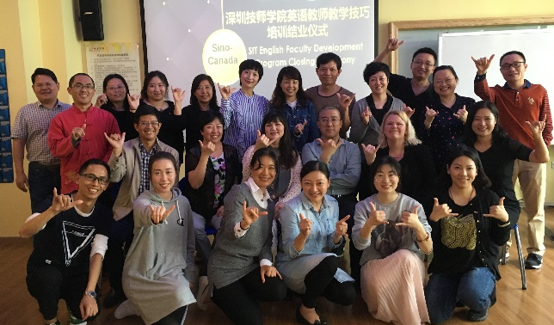

Executive Summary

This proposal presents a sample of a progressive training program for post-secondary faculty in China. The program is designed to help build capacity in your institution. This program is delivered in a blended format (including on-line and face to face instruction). The goal of this training program is to provide the participants with a learning experience on a variety of topics to enhance their technical teaching, learning strategies and research competencies.

Customized Training

As this is a fully customized program, this proposal presents only a sample of the training available. Georgian College will work with your organization to ensure the materials have the greatest impact. We are committed to your success. Some key customizations that are available:

Delivery at your institution

Length of the program 2-12 weeks

Start Date of the Program

Translation services

Mentorship program with Canadian faculty

Increased English language content to support faculty fluency

Program content focus to support the goals of your institution

Programming at the English level you need

Georgian College Expertise
With fifty years of experience as a provider of quality education and training, Georgian has immediate and broad access to an enviable range of training, consulting, and education resources. Many of our staff have masters of education and/or training degrees and all have taken advantage of the excellent ongoing professional development available to them in the areas of curriculum development, adult learning, and specific subject matter training. We have designed and developed comprehensive training programs for numerous sector groups, individual corporate clients, governments, institutions, and organizations.

Georgian College applies all aspects of sound curriculum and program development practices to the design and development of programs. We have an extensive range of subject matter experts and curriculum specialists to draw on through our external network as well as through our Centre for Teaching and Learning.

Training Outline

We collaboratively consult with your institution(s) to ensure that the specific educational

development needs of your students are central to the faculty skills targeted in the training.

Georgian can add additional content or specific program development outcomes to help build

capacity in your organization.

Adult Education & Skill Development Frameworks (30 hours) (15 in 2 week)

Foundations of Adult Education: The Canadian Context & Comparative Framework (6 hours)

Discovering Our Many Intelligences & Cognitive Processes (3 hours)
  - Course and Program Development: Planning for Student Success (6 hours)
  - Curriculum Design for Adult Learners (6 hours)
  - Designing Outcome Based Assessment and Evaluation Tools (6 hours)
This course introduces assessment and evaluation strategies based on adult learning theories and practices. Participants apply concepts about assessment in developing evaluation methods suitable for different types of learning in both the classroom and workplace.
Participants apply concepts about assessment in developing evaluation methods suitable for different types of learning. The Kirkpatrick model will be reviewed as an approach to evaluating training.
The focus in this session is on the design aspects of assignments, tests, and other assessment techniques. Evaluation methods should all align with course outcomes and help learners build knowledge and skills. Learners are exposed to a number of resources and strategies for designing or evaluating assignments.

  - Classroom Observations (3 hours)
Participants observe post-secondary program delivery in similar areas of expertise. Students observe colleagues engaging adult learners by creating and maintaining a positive learning climate is a challenge in any instructional setting. The impact of adult learning theories and styles on student engagement will be discussed and demonstrated. Participants in this course learn how they can increase levels of student engagement and continue to apply various adult learning strategies.

Instructional Skills Series Choice of 5 (45 hours) (or 3 @27 hours in 2 week)
Each nine hour intensive skill workshop is broken down into three components:
- 3 Hours on Methodology,
- 3 Hours on Application & Demonstration using Video, and
- 3 hours on Feedback and Reflection.

Video is used as a tool to effectively reflect on instructional skills, and to receive feedback.
A four week program includes five skills workshops, while a two week program includes three.
- Advanced Facilitation Skills: Encouraging Active Learning (9)
- Advanced Facilitation Skills: Using technology to enhance student learning (9)
- Advanced Facilitation Skills: Effective Use of Groups (9)
- Advanced Facilitation Skills: Instructional Skills for Large Classes (9)
- Advanced Facilitation Skills: Multi-level Classroom Strategies (9)
- Advanced Facilitation Skills: Leveraging Classroom Diversity (9)
- Advanced Facilitation Skills: Debriefing to Maximize Student Learning (9)
- Advanced Facilitation Skills: Teaching with Power Point (9)
- Advanced Facilitation Skills: Effectively taking learning outside of the classroom into the community (9)

Lifelong Learning Series 24 hours (12 in 2 week)
- Trends and Issues in Adult Learning (12 hours)
This professional dialogue includes topics like: skills for tomorrow’s workforce, on-line and blended programming, work integrated learning frameworks, and the millennial learner.
At the end of every day, the group will participate in a knowledge exchange; this is a process that brings together teams to exchange ideas, evidence and expertise. This knowledge exchange process involves the opportunity for dynamic information sharing and exchange amongst the group.
Participants meet and discuss the areas of interest, different perspectives, items that require clarification, tool and tips and how to implement learning in the field. Through mutual exchange and collaboration, this process benefits academic teaching and research.
- Research and Professional Development (6 hours)
Applied research allows faculty to bring expertise to industry and to bring industry experiences to students. As a faculty researcher, you supervise and mentor students to ensure high quality results that meet the needs of industry partners. Research projects provide faculty with opportunities for professional development, networking and academic engagement.
Participants learn from researchers how to find the research opportunities, define the project, determine resources required for success, and secure funding opportunities.

- Faculty Development Plans (6 hours)

- Faculty Mentorship Program (Not included in training hours: 4 weeks @ 3 hours/week = 12 hours)
Georgian will provide 4 weeks of our faculty mentorship program after the classroom portion of the program. This is to guide faculty in the implementation of new methods or technology into their classrooms. Our mentorship program is a based on teacher coaching model that uses reflective guided dialogues between Georgian faculty and your faculty. Using We Chat, Iris Connect or What’s App as a platform, mentees are taken through bi-weekly modules of personal reflection and individual coaching on the implementation of effective instructional practices in the classroom.

Additional Program Features
- 3 hour orientation;
- 3 hour downtown orientation/building a learning community;
- 3 hours closing ceremony;
- Team Assignment & Final Presentation 12 hours (6 hours in 2 week);
- TOTAL: 21 hours programming (15 for 2 week)
Total Program hours

(30 hours/week for 2 weeks =60 hour)

(30 hours/week for 4 weeks=120 hours)

Scheduled time blocks: 9-12 and 1-4, Monday to Friday

Training Methodology | Teaching methodology supports adult learning theory and principles while respecting participants’ various learning styles. Training examples and scenarios/exercises can be customized to meet the specific needs of customers.
Number of Participants | 15+ (Costs vary with participant numbers). Please ask for rates on additional numbers.
Total Training Hours | 140 Hours (includes online and in class learning)
Location of Training | Online – China  Onsite - Georgian College, Barrie, Ontario, Canada | Delivered at your institution
Costs | For the complete program costs, inclusions and details, please contact us at internationalworkforce@georgiancollege.ca

